JECRC
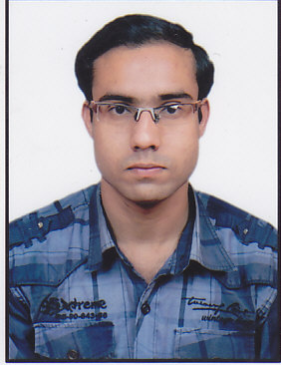

size photograph
JAIPUR

INDIVIDUAL FACULTY DATA SHEET
Name of the faculty member | : | SUMIT SAINI
Present Designation | : | ASSISTANT PROFESSOR
Email Id: sumitsaini.ce@jecrc.ac.in
Contact Details: 8387001650

I. Particulars of Educational Qualification: (only completed)

Category | Name of the Degree | Specialization | Year of Passing | Name of the College | Name of the University
UG | B.TECH | MECHANICAL ENGINEERING | 2013 | RCERT | RTU KOTA
PG
Ph.D.

II. Academic Experience : 5 YEARS

III. Industrial Experience : NIL

IV. Title of Ph.D. Thesis : NIL

V. Awards/Achievements : NIL

VI. Research/Specialization : NIL

VII. Course Taught : MECHANICAL ENGINEERING

VIII. Refereed International Journal Publication : NIL

IX. International Conference Proceeding : NIL

X. Books Written : NIL

XI. M.Tech Thesis Guide : NIL

XII. PHD Thesis Guide : NIL

XIII. Professional Body Membership : NIL

